# Exercises: Introduction to HTML

## Welcome to HTML

Create a Web Page like the following:

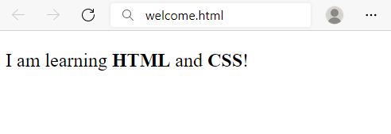

Create file named welcome.html.

## Fruits

Create a Web Page like the following:

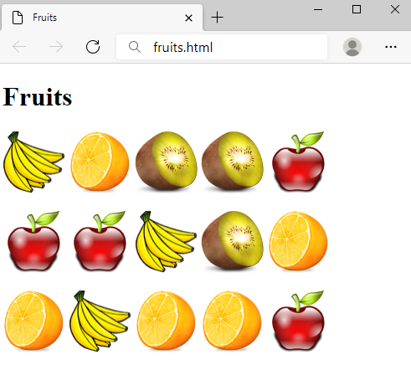

Create a file fruits.html.

## Wiki Page

Create a Web Page like the following:

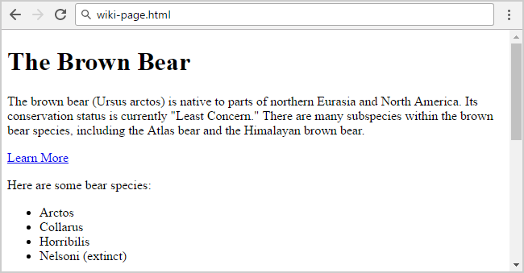

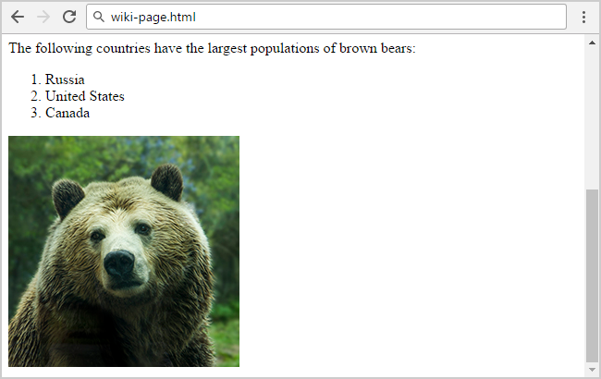

Create file: wiki-page.html.

## HTML Lists

Create a Web Page like the following:

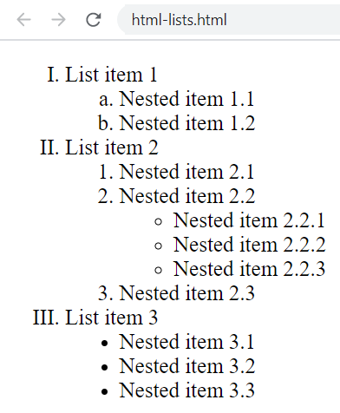

Create file: html-lists.html.

## Definition Lists

Create a Web Page like the following:

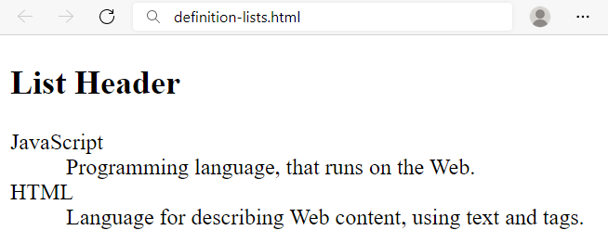

Create a file named definition-lists.html.